Larry Syms

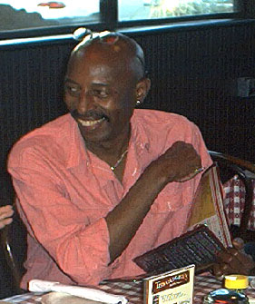

When Larry Syms, a man who had worked for many years in Boston area health care institutions, and the father of two grown boys, decided to become a VISTA volunteer, he hoped that this might be an opportunity for training and access to a new career as a graphic artist in information technology. He also hoped it would be a way of helping others to learn about and share the joy and power in using computers. He knew it wasn’t going to swell his bank account, but that wasn’t important.

Larry didn’t know that his work as a VISTA would be so important to him, that he would be able to help so many people, that he would be admired and loved by adult learners, teachers, and other colleagues at the Adult Literacy Resource Institute, and in the VISTA project.

Larry had vision. As he was considering VISTA, I told him we could help him out with transportation – either by providing an MBTA subway Pass – or paying for him to go to San Diego for the VISTA project national conference. He didn’t hesitate. The broad smile and a twinkling eye of someone who had for many years been a world traveler, told me he had chosen San Diego – and, I learned later, a brief trip to Mexico. Larry’s earlier years of travel abroad, and his friendships with people from other cultures, living in countries where little English was spoken, had strengthened his cultural sensitivity, opened him to new ideas, and helped him appreciate cultural differences. In quiet, ways, Larry always showed curiosity, caring, and respect. Ngaio Schiff, a teacher at the Somerville Center for Adult Learning experience (SCALE), wrote that she thought “He had a gentleness of spirit and a peace about him that put others at ease.”

The vision of a larger world, cultural sensitivity, and respect, combined with a fascination with the power of computers, and a love of graphic arts and music made him the ideal person to work with immigrants in the Boston area who wanted to learn English and to use computers. He also worked successfully with adults who were returning for basic skills brush-up and job skills preparation classes. In one of these settings, at Project Place, Larry found a young man who was gifted in drawing. Larry showed him how to use a simple computer graphics program, and within a short time this fellow had taught himself the skills to get a job as a graphic artist at a Boston company. Larry was especially pleased about this.

Larry helped new Bostonians at the International Institute of Boston, the Community Learning Center in Cambridge, and at SCALE who spoke little or no English and who had no computer experience, to feel comfortable with technology and to use it as part of their English language learning.

Larry’s sudden illness and rapid decline in the summer of 2003 brought great sadness to the students and colleagues who had become his friends. Priscilla Lee, a teacher at the Community learning Center (CLC), wrote me “The very week that Larry passed away I found a card from him in my CLC mailbox….It was a birthday card and the card was brief, but the last lines in Larry's handwriting read, "But, love was in my eyes for all secretly! P.S. A hidden Buddhist!" Priscilla also wrote “there was a lot going on beneath the surface- he had so much love and creative energy and at the same time was very humble about it all. I think he was very much aware in those last months of just how much love he had and how much he shared ("secretly").

When I last saw Larry, just days before he died, he proudly pulled out of his refrigerator a fish that he had caught the day before in a covert expedition to Cape Cod. Larry succeeded in living fully and loving others to the very end. In that, and in many other things, he was a model for us all.

